**IRR of the Mutual Fund as of Ashad 2082**



Prepared By:

Research Department

Sanima Capital Limited

[Company]

IRR report of the mutual fund

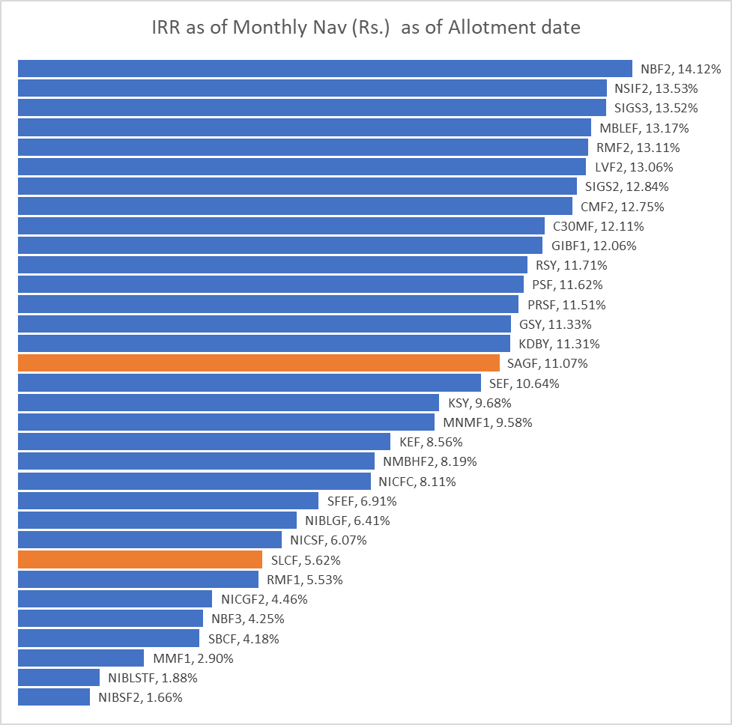

## Performance Analysis Summary

**Top Performers (Above 12% IRR):**

* **NBF2** leads with **14.12% IRR**, showing the strongest performance
* **NSIF2** (13.53%) and **SIGS3** (13.52%) follow closely
* **MBLEF** (13.17%), **RMF2** (13.11%), and **LVF2** (13.06%) round out the top tier

**Mid-Range Performers (10-12% IRR):**

* Several funds cluster in the 11-12% range, including SIGS2, CMF2, C30MF, GIBF1, RSY, PSF, and PRSF
* This group represents solid, consistent performance

**Lower Performers (Below 10% IRR):**

* **SEF** (10.64%) marks the transition to single-digit returns
* Several funds show concerning performance: NBSF2 (1.66%), NIBLSTF (1.88%), MMF1 (2.90%)

## Key Observations:

1. **Performance Spread**: Wide variation from 14.12% (NBF2) to 1.66% (NBSF2), indicating significant differences in fund management and strategy effectiveness
2. **Highlighted Funds**: SAGF (11.07%) and SLCF (5.62%) appear highlighted in orange, possibly indicating specific attention or concern
3. **Market Concentration**: Most funds (18 out of 29) achieved IRR above 10%, suggesting generally favorable market conditions